12.43: a) From Eq. (12.12),
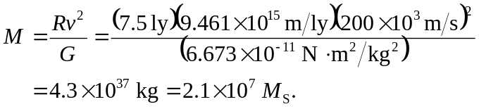

b) It would seem not.

c) 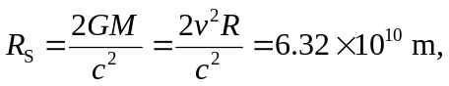

which does fit.

